3 15 24 28 50 78 83 99 126 143 152 152 164 169 180 190 214 226 253 260 276 285 296 311 328 348 370 377 387 398 428 444 462 491 514 521 542 571 587 591 1 1 1 1 1 1 1 1 1 1 1 1 1 1 1 1 1 1 1 1 1 1 1 1 1 1 1 1 1 1 1 1 1 1 1 1 1 1 1 1 1 1 1 1 1 1 1 1 1 1 1 1 1 1 1 1 1 1 1 1 1 1 1 1 1 1 1 1 1 1 1 1 1 1 1 1 1 1 1 1 1 1 1 1 1 1 1 1 1 1 1 1 1 1 1 1 1 1 1 1 1 1 1 1 1 1 1 1 1 1 1 1 1 1 1 1 1 1 1 1 1 1 1 1 1 1 1 1 1 1 1 1 1 1 1 1 1 1 1 1 1 1 1 1 1 1 1 1 1 1 1 1 1 1 1 1 1 1 1 1 1 1 1 1 1 1 1 1 1 1 1 1 1 1 1 1 1 1 1 1 1 1 1 1 1 1 1 1 1 1 1 1 1 1 1 1 1 1 1 1 1 1 1 1 1 1 1 1 1 1 1 1 1 1 1 1 1 1 1 1 1 1 1 1 1 1 1 1 1 1 1 1 1 1 1 1 1 1 1 1 1 1 1 1 1 1 1 1 1 1 1 1 1 1 1 1 1 1 1 1 1 1 1 1 1 1 1 1 1 1 1 1 1 1 1 1 1 1 1 1 1 1 1 1 1 1 1 1 1 1 1 1 1 1 1 1 1 1 1 1 1 1 1 1 1 1 1 1 1 1 1 1 1 1 1 1 1 1 1 1 1 1 1 1 1 1 1 1
37 58 73 99 118 144 150 173 191 206 221 237 265 271 300 313 323 343 366 383 412 429 450 454 480 499 495 487 484 477 469 467 460 454 448 442 433 424 415 415 1 1 1 1 1 1 1 1 1 1 1 1 1 1 1 1 1 1 1 1 1 1 1 1 1 1 1 1 1 1 1 1 1 1 1 1 1 1 1 1 1 1 1 1 1 1 1 1 1 1 1 1 1 1 1 1 1 1 1 1 1 1 1 1 1 1 1 1 1 1 1 1 1 1 1 1 1 1 1 1 1 1 1 1 1 1 1 1 1 1 1 1 1 1 1 1 1 1 1 1 1 1 1 1 1 1 1 1 1 1 1 1 1 1 1 1 1 1 1 1 1 1 1 1 1 1 1 1 1 1 1 1 1 1 1 1 1 1 1 1 1 1 1 1 1 1 1 1 1 1 1 1 1 1 1 1 1 1 1 1 1 1 1 1 1 1 1 1 1 1 1 1 1 1 1 1 1 1 1 1 1 1 1 1 1 1 1 1 1 1 1 1 1 1 1 1 1 1 1 1 1 1 1 1 1 1 1 1 1 1 1 1 1 1 1 1 1 1 1 1 1 1 1 1 1 1 1 1 1 1 1 1 1 1 1 1 1 1 1 1 1 1 1 1 1 1 1 1 1 1 1 1 1 1 1 1 1 1 1 1 1 1 1 1 1 1 1 1 1 1 1 1 1 1 1 1 1 1 1 1
27 23 13 8 0 0 7 15 32 41 63 93 122 149 157 162 189 213 213 237 249 269 279 283 307 329 331 336 343 373 384 394 415 444 454 478 482 483 483 505 1 1 1 1 1 1 1 1 1 1 1 1 1 1 1 1 1 1 1 1 1 1 1 1 1 1 1 1 1 1 1 1 1 1 1 1 1 1 1 1 1 1 1 1 1 1 1 1 1 1 1 1 1 1 1 1 1 1 1 1 1 1 1 1 1 1 1 1 1 1 1 1 1 1 1 1 1 1 1 1 1 1 1 1 1 1 1 1 1 1 1 1 1 1 1 1 1 1 1 1 1 1 1 1 1 1 1 1 1 1 1 1 1 1 1 1 1 1 1 1 1 1 1 1 1 1 1 1 1 1 1 1 1 1 1 1 1 1 1 1 1 1 1 1 1 1 1 1 1 1 1 1 1 1 1 1 1 1 1 1 1 1 1 1 1 1 1 1 1 1 1 1 1 1 1 1 1 1 1 1 1 1 1 1 1 1 1 1 1 1 1 1 1 1 1 1 1 1 1 1 1 1 1 1 1 1 1 1 1 1 1 1 1 1 1 1 1 1 1 1 1 1 1 1 1 1 1 1 1 1 1 1

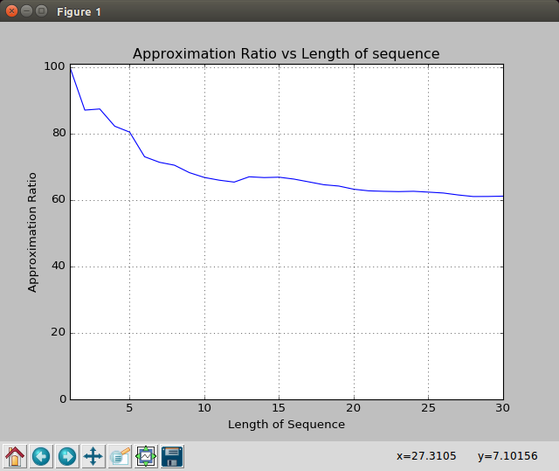

5 8 10 15 15 16 18 20 12 11 10 8 14 20 19 19 22 1 1 1 1 1 1 1 1 1 1 1 1 1 1 1 1 1 1 1 1 1 1 1 1 1 1 1 1 1 1 1 1 1 1 1 1 1 1 1 1 1 1 1 1 1 1 1 1 1 1 1 1 1 1 1 1 1 1 1 1 1 1 1 1 1 1 1 1 1 1 1 1 1 1 1 1 1 1 1 1 1 1 1 1 1 1 1 1 1 1 1 1 1 1 1 1 1 1 1 1 1 1 1 1 1 1 1 1 1 1 1 1 1 1 1 1 1 1 1 1 1 1 1 1 1 1 1 1 1 1 1 1 1 1 1 1 1 1 1 1 1 1 1 1 1 1 1 1 1 1 1 1 1 1 1 1 1 1 1 1 1 1 1 1 1 1 1 1 1 1 1 1 1 1 1 1 1 1 1 1 1 1 1 1 1 1
6 9 11 10 15 15 16 18 20 12 11 13 13 12 11 10 8 1 1 1 1 1 1 1 1 1 1 1 1 1 1 1 1 1 1 1 1 1 1 1 1 1 1 1 1 1 1 1 1 1 1 1 1 1 1 1 1 1 1 1 1 1 1 1 1 1 1 1 1 1 1 1 1 1 1 1 1 1 1 1 1 1 1 1 1 1 1 1 1 1 1 1 1 1 1 1 1 1 1 1 1 1 1 1 1 1 1 1 1 1 1 1 1 1 1 1 1 1 1 1 1 1 1 1 1 1 1 1 1 1 1 1 1 1 1 1 1 1 1 1 1 1 1 1 1 1 1 1 1 1
4 7 9 6 9 11 13 13 12 11 10 8 14 20 19 19 18 18 1 1 1 1 1 1 1 1 1 1 1 1 1 1 1 1 1 1 1 1 1 1 1 1 1 1 1 1 1 1 1 1 1 1 1 1 1 1 1 1 1 1 1 1 1 1 1 1 1 1 1 1 1 1 1 1 1 1 1 1 1 1 1 1 1 1 1 1 1 1 1 1 1 1 1 1 1 1 1 1 1 1 1 1 1 1 1 1 1 1 1 1 1 1 1 1 1 1 1 1 1 1 1 1 1 1 1 1 1 1 1 1 1 1 1 1 1 1 1 1 1 1 1 1 1 1 1 1 1 1 1 1 1
6 6 4 7 8 12 14 22 34 7 9 14 20 19 19 18 18 1 1 1 1 1 1 1 1 1 1 1 1 1 1 1 1 1 1 1 1 1 1 1 1 1 1 1 1 1 1 1 1 1 1 1 1 1 1 1 1 1 1 1 1 1 1 1 1 1 1 1 1 1 1 1 1 1 1 1 1 1 1 1 1 1 1 1 1 1 1 1 1 1 1 1 1 1 1 1 1 1 1 1 1 1 1 1 1 1 1 1 1 1 1 1 1 1 1 1 1 1 1 1 1 1 1 1 1 1 1 1 1 1 1 1 1 1 1 1 1 1 1 1 1 1 1 1 1 1 1 1 1 1 1 1 1

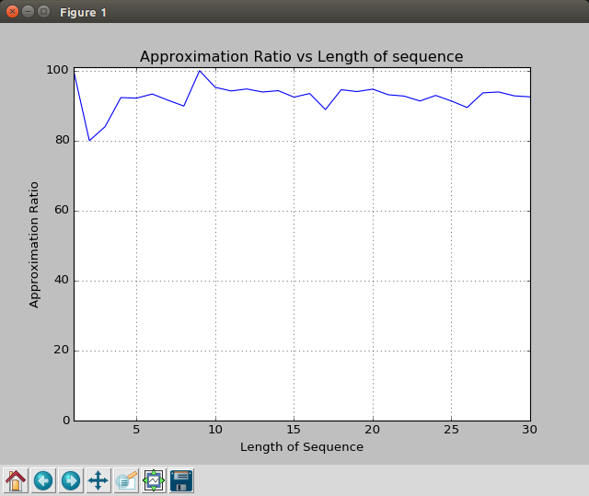

5 2 6 8 13 20 20 21 32 25 15 1 1 1 1 1 1 1 1 1 1 1 1 1 1 1 1 1 1 1 1 1 1 1 1 1 1 1 1 1 1 1 1 1 1 1 1 1 1 1 1 1 1 1 1 1 1 1 1 1 1 1 1 1 1 1 1 1 1 1 1 1 1 1 1 1 1 1 1 1 1 1 1 1 1 1 1 1 1 1 1 1 1 1 1 1 1 1 1 1 1 1 1 1 1 1 1 1 1 1 1 1 1 1 1 1 1 1 1 1 1 1 1 1 1 1 1 1 1 1 1 1 1 1 1 1 1 1 1 1 1 1 1 1 1 1 1 1 1 1 1 1 1 1 1 1 1 1 1 1 1 1 1 1 1 1 1 1 1 1 1 1 1 1 1 1 1 1 1 1 1 1 1 1 1 1 1 1 1 1 1 1 1 1 1 1 1 1 1 1 1 1 1 1 1 1 1 1 1 1 1 1 1 1 1 1 1 1 1 1 1 1 1 1 1 1 1 1 1 1 1 1 1 1 1 1 1 1 1 1 1 1 1 1 1 1 1 1 1 1 1 1 1 1 1 1
6 9 11 10 15 15 16 18 20 35 11 13 13 12 11 10 8 1 1 1 1 1 1 1 1 1 1 1 1 1 1 1 1 1 1 1 1 1 1 1 1 1 1 1 1 1 1 1 1 1 1 1 1 1 1 1 1 1 1 1 1 1 1 1 1 1 1 1 1 1 1 1 1 1 1 1 1 1 1 1 1 1 1 1 1 1 1 1 1 1 1 1 1 1 1 1 1 1 1 1 1 1 1 1 1 1 1 1 1 1 1 1 1 1 1 1 1 1 1 1 1 1 1 1 1 1 1 1 1 1 1 1 1 1 1 1 1 1 1 1 1 1 1 1 1 1 1 1 1 1 1 1 1 1 1 1 1 1 1 1 1 1 1 1 1 1 1 1 1 1 1 1 1 1 1 1 1 1 1 1 1 1 1 1 1 1 1 1 1 1 1 1 1 1 1 1 1 1 1 1 1 1 1 1 1 1 1 1 1 1 1 1 1 1 1 1 1 1 1 1 1 1 1 1 1 1 1 1 1 1 1 1 1 1 1 1 1 1 1 1 1 1 1 1 1 1 1 1 1 1 1 1 1 1 1 1 1 1 1 1 1 1
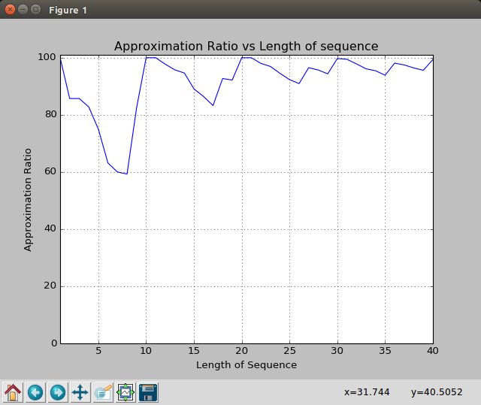
1 2 6 8 13 15 20 20 21 32 25 15 1 1 1 1 1 1 1 1 1 1 1 1 1 1 1 1 1 1 1 1 1 1 1 1 1 1 1 1 1 1 1 1 1 1 1 1 1 1 1 1 1 1 1 1 1 1 1 1 1 1 1 1 1 1 1 1 1 1 1 1 1 1 1 1 1 1 1 1 1 1 1 1 1 1 1 1 1 1 1 1 1 1 1 1 1 1 1 1 1 1 1 1 1 1 1 1 1 1 1 1 1 1 1 1 1 1 1 1 1 1 1 1 1 1 1 1 1 1 1 1 1 1 1 1 1 1 1 1 1 1 1 1 1 1 1 1 1 1 1 1 1 1 1 1 1 1 1 1 1 1 1 1 1 1 1 1 1 1 1 1 1 1 1 1 1 1 1 1 1 1 1 1 1 1 1 1 1 1 1 1 1 1 1 1 1 1 1 1 1 1 1 1 1 1 1 1 1 1 1 1 1 1 1 1 1 1 1 1 1 1 1 1 1 1 1 1 1 1 1 1 1 1 1 1 1 1 1 1 1 1 1 1 1 1 1 1 1 1 1 1 1 1 1 1 1

